1-5 Assignment: UML Diagrams

Blake Merry
Southern New Hampshire University
CS-230 Operating Platforms
Prof. David McCullough
July 5, 2026
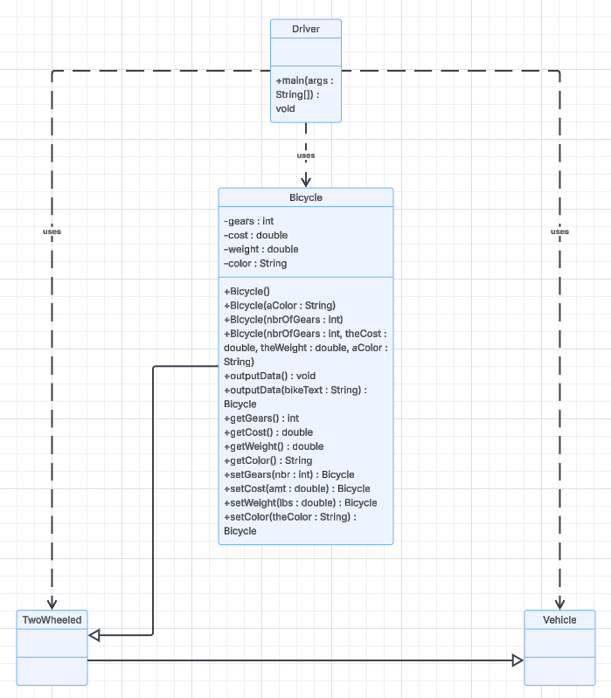
The class diagram demonstrates several core object-oriented programming principles through the relationships between classes. The clearest example is inheritance, where Bicycle extends TwoWheeled, which extends Vehicle. Even though Vehicle and TwoWheeled don’t currently have any attributes or methods, they establish a hierarchy that could be expanded later.
The diagram also shows encapsulation in the Bicycle class. The instance variables are marked as private, so they can’t be accessed directly from outside the class. Instead, public getter and setter methods provide controlled access to the object’s data. The overloaded constructors also demonstrate how a Bicycle object can be created in different ways depending on the information available.
Finally, the Driver class demonstrates how classes interact without being part of the inheritance hierarchy. Rather than extending another class, it creates and uses instances of the other classes to test their behavior. Overall, the design illustrates how inheritance, encapsulation, and well-defined class relationships help organize code into a structure that is easier to understand, reuse, and maintain.

